Game Design Document

Fill up the following document

1. Write the title of your project.

2D Platformer Game.

1. What is the goal of the game?

Saving friends.

1. Write a brief story of your game.

The player is an army officer and has to save one of his friends from enemies.

The game has various checkpoints and gives player certain powers at certain point of time.

1. Which are the playing characters of this game?

* Playing characters are the ones who respond to the user based on the input from the user.
* Cars, monkeys, dinos, wizards, etc., are the playing characters in the game.

|  |  |  |
| --- | --- | --- |
| Number | Character Name | What can this character do? |
| 1 | Army Officer | He can move with key inputs , shoot bullets as well as jump. |
| 2 |  |  |
| 3 |  |  |
| 4 |  |  |
| 5 |  |  |
| 6 |  |  |
| 7 |  |  |
| 8 |  |  |

1. Which are the Non-Playing Characters of this game?

* Non-Playing characters are the ones that don't have an action or behavior when the user interacts with the game.
* Hurdles, stones, bananas, coins, etc., are non-playing characters in the game.

|  |  |  |
| --- | --- | --- |
| Number | Character Name | What can this character do? |
| 1 | Enemy with sword | Has the power to give damage to our player |
| 2 | Enemey with armor and sword | Gives more damage to our player |
| 3 | Main Boss | Attacks as well as defends our player character and also has suuper power. |
| 4 |  |  |
| 5 |  |  |
| 6 |  |  |
| 7 |  |  |
| 8 |  |  |

Draw your imagination of this game. What does this game look like?

* Draw the game either on your computer or on paper.
* Add images of the game scenes to show each of the playing and non-playing characters at least once.

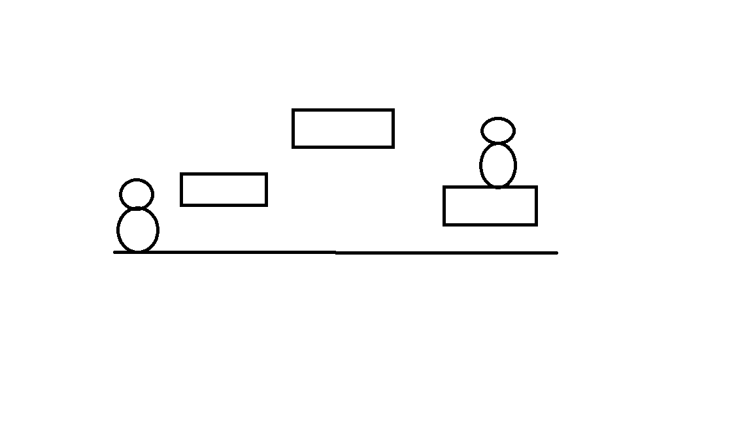

How do you plan to make your game engaging?

By creating various levels and checkpoints as well as different level of enemies and giving the main enemy super power to make the game challenging.